5: Job Application - Zoho Creator Reports Suite

Aim:
To design and build a complete suite of Reports in Zoho Creator for the "Job Application" application, demonstrating the correct usage of all nine Report Types available in Zoho Creator.

Reports Used Overview
Report Type | Report Name
List View | Loan Application Report
Spreadsheet View | Loan_Applications_Spreadsheet
Kanban View | Loan_Status_Kanban
Calendar View | Callback_Schedule_Calendar
Map View | Applicant_Residential_Map
Timeline View | Application_Activity_Timeline
Pivot Table | LoanType_By_EmploymentType_Pivot
Chart View | LoanType_Distribution_Chart
Summary View | Loan_Wise_Summary

Detailed Report Descriptions
- job Application Report (List View)
  - Purpose: Default landing report for the Loan Processing Cell, displaying all loan applications in a clean, searchable tabular format.
  - Features: Includes a global search bar, sorting options, and column-level filters for applicant details, PAN numbers, email addresses, contact numbers, residential addresses, and employment types.

- job_Applications_Spreadsheet (Spreadsheet View)
  - Purpose: Utilized daily by loan officers to review and update application parameters quickly in a grid layout.
  - Features: Allows inline editing for specific verification and employment fields while keeping baseline applicant details read-only for data integrity.
- job_Status_Kanban (Kanban View)
  - Purpose: Provides a visual pipeline for tracking how loan applications progress through various review stages (e.g., Choice 1, Choice 2, Choice 3, and Deleted & Others).
  - Features: Cards can be dragged across columns to automatically update the underlying status field.
- Callback_Schedule_Calendar (Calendar View)
  - Purpose: Used by loan officers and customer support to monitor and manage scheduled client callbacks, follow-ups, and interview dates.
  - Features: Monthly, weekly, and daily grid views allowing quick identification of scheduled appointments.
- Applicant_Residential_Map (Map View)
  - Purpose: Deployed by the regional lending team to visualize the geographical distribution of applicants across regions like Chennai and surrounding areas.
  - Features: Geocode-enabled pin placement to identify high-density application zones and plan local financial outreach.
- Application_Activity_Timeline (Timeline View)
  - Purpose: Enables management to track application inflow velocity and user activities across specific hours and days of the week.
  - Features: Chronological breakdown highlighting peak periods of application submissions.

- jobType_By_EmploymentType_Pivot (Pivot Table)
  - Purpose: Summarizes relationships between applicant birth years, names, and aggregate metrics to analyze demographic distributions.
  - Features: Provides matrix totals and grand counts for comparative internal review.

- jobType_Distribution_Chart (Chart View)
  - Purpose: Visually compares loan distributions and demographic categories across applicants using interactive graphical nodes and filters.
  - Features: Dynamic sorting and multi-legend filters for PAN numbers and applicant attributes.
- job_Wise_Summary (Summary View)
  - Purpose: Aggregates core loan portfolio metrics to support credit committee evaluations and limit planning.
  - Features: Displays calculated totals and category groupings for quick executive summaries.
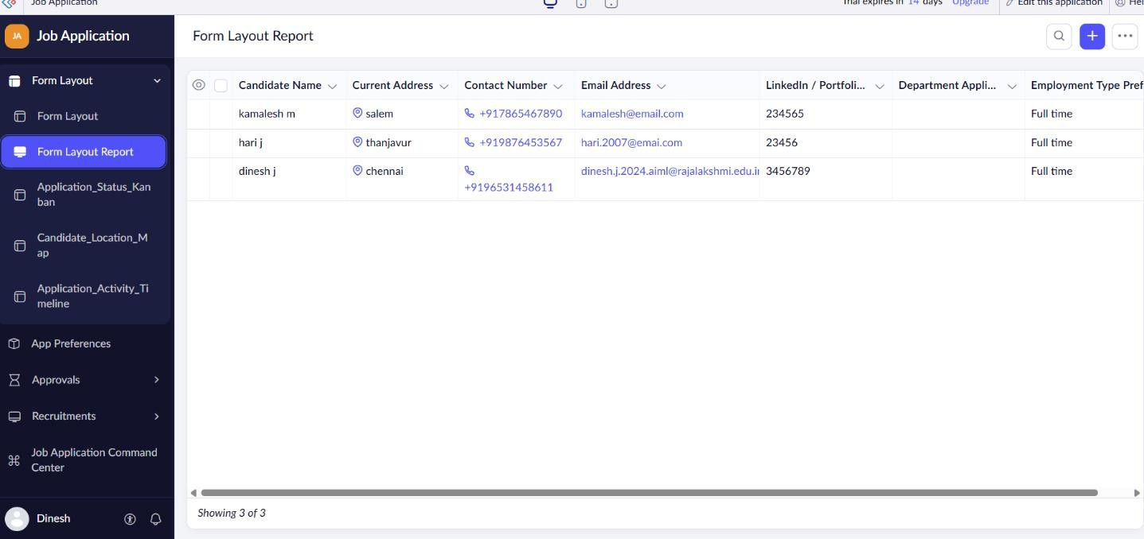
Screecshots:

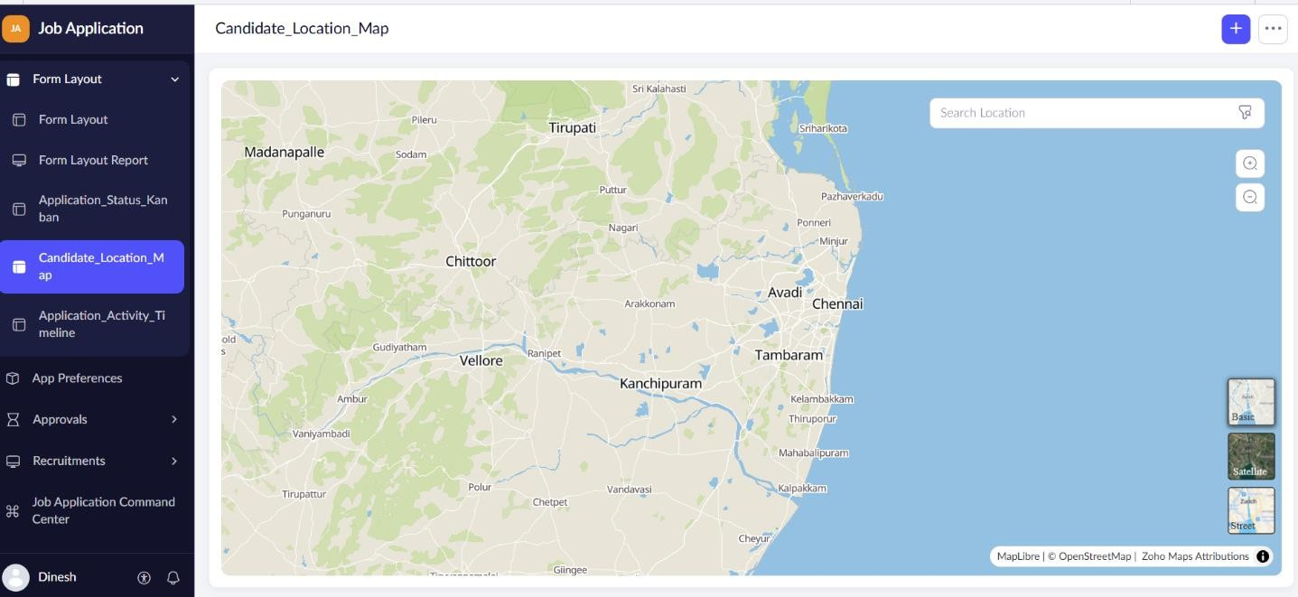

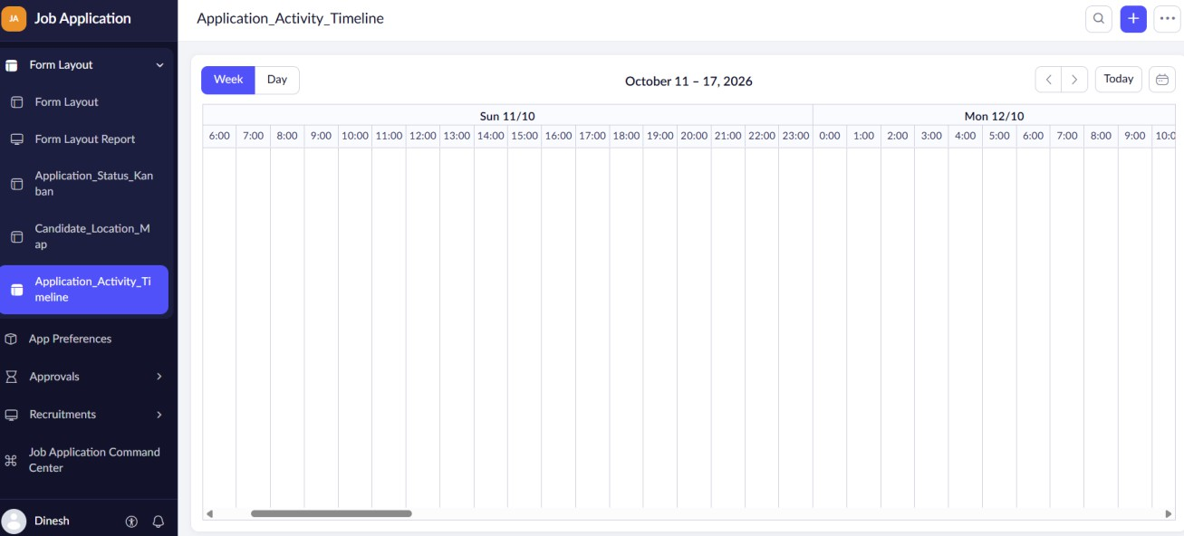

Result:
A complete suite of nine custom Zoho Creator reports for the Job Application project has been successfully configured, verified, and documented.

